Mini Project Report On
“Campus Skill Exchange & Peer Learning Management System”
Submitted by:
Name : Nisarg Rajurkar (PRN No :RBT25CB018)
Name :Jaywant Deshmukh (PRN No: RBT25CB007)
Under the guidance of
Prof. Rutuja S. Bachhav
Course: DBMS
Academic Year: 2026–27 (Semester III)

Table of Contents
1. Abstract 5
2. Introduction 6
3. Literature Survey / Existing System 7
4. Proposed System 8
5. Methodology / Implementation 10
6. Results and Discussion 18
7. Conclusion and Future Scope 21
8. References 22
9. Appendix 23
1. Course Outcomes
CO1: Design a database schema and 2-tier application for a given problem statement.
CO2: Design SQL DDL/DML queries to create, secure, populate, maintain, and query a database using integrity constraint, stored function/procedure, cursor, trigger using PL/SQL block.
CO3: Design NoSQL query using MongoDB platform.
2. PO Mapped
PO1: Engineering Knowledge: Apply knowledge of mathematics, natural science, computing, engineering fundamentals and an engineering specialization as specified in WK1 to WK4 respectively to develop to the solution of complex engineering problems.
PO2: Problem Analysis: Identify, formulate, review research literature and analyze complex engineering problems reaching substantiated conclusions with consideration for sustainable development.
PO3: Design/Development of Solutions: Design creative solutions for complex engineering problems and design/develop systems/components/processes to meet identified needs with consideration for the public health and safety, whole-life cost, net zero carbon, culture, society and environment as required.
PO4: Conduct Investigations of Complex Problems: Conduct investigations of complex engineering problems using research-based knowledge including design of experiments, modeling, analysis & interpretation of data to provide valid conclusions.
PO5: Engineering Tool Usage: Create, select and apply appropriate techniques, resources and modern engineering & IT tools, including prediction and modeling recognizing their limitations to solve complex engineering problems.
PO8: Individual and Collaborative Team work: Function effectively as an individual, and as a member or leader in diverse/multi-disciplinary teams.
PO9: Communication: Communicate effectively and inclusively within the engineering community and society at large, such as being able to comprehend and write effective reports and design documentation, make effective presentations considering cultural, language, and learning differences.
PO10: Project Management and Finance: Apply knowledge and understanding of engineering management principles and economic decision-making and apply these to one’s own work, as a member and leader in a team, and to manage projects and in multidisciplinary environments.
PO11: Life-Long Learning: Recognize the need for, and have the preparation and ability for i) independent and life-long learning ii) adaptability to new and emerging technologies and iii) critical thinking in the broadest context of technological change.
3. PSO Mapped
PSO 1: Integrated Technical Proficiency: Ability to analyze, designs, and implement comprehensive software and business systems using modern tools and techniques, ensuring intelligent, efficient, and sustainable solutions.
PSO 2: Data-Driven Decision Making: Ability to apply mathematical and data analytics methods including algorithms, statistical models, and data structures to solve complex computational and business problems and support innovation.
PSO 3: Interdisciplinary Collaboration & Professionalism: Ability to effectively collaborate in multidisciplinary teams, integrating technical and business perspectives, and to communicate and manage projects with professional ethics and societal responsibility.
4. SDG Goals Mapped
SDG 4: Quality Education: Develops students’ practical skills in database design, SQL, PL/SQL, NoSQL, and modern database technologies.
SDG 8: Decent Work and Economic Growth: Enhances students’ technical and problem-solving skills required for employment and professional development in the IT industry.
SDG 9: Industry, Innovation and Infrastructure: Promotes the development of technology-based database solutions using SQL, PL/SQL, and MongoDB.
SDG 12: Responsible Consumption and Production: Encourages efficient data management, storage, and utilization of computing resources.

1. Abstract
Students in a college often possess skills that their classmates want to learn, yet there is no organised way to discover who can teach what. Peer help therefore stays limited to personal friend circles and informal chat groups. This mini project, the Campus Skill Exchange & Peer Learning Management System, addresses the problem with a database-driven web application built using Flask and MySQL.
The system lets a student register, list the skills he or she can teach and the skills he or she wants to learn, and receive automatic matches from other students. A learner can send a learning request, the teacher can accept or reject it, and an accepted request can be turned into a scheduled online or offline session. After the session, participants submit a rating and a comment, and the average rating helps rank mentors in later searches.
The back end is a normalised relational schema of nine tables. It uses primary, foreign and composite keys, UNIQUE, CHECK and ENUM constraints, and cascading deletes to protect integrity. The matching logic is written in SQL using JOIN, GROUP BY and aggregate functions. Passwords are stored as salted hashes, and all queries are parameterised. The project demonstrates the practical use of relational database design, SQL querying and a two-tier application, and provides a base for extensions such as triggers, stored procedures and a MongoDB notification store.

2. Introduction

2.1 Background / Motivation
A college campus brings together students with very different strengths. One student may be good at Python, another at graphic design, and a third at public speaking. Research on peer tutoring in higher education reports benefits for both the student who explains and the student who learns (Topping, 1996). Despite this, students usually find a peer mentor only by chance, through friends, class groups or notice boards.
A database is the natural tool for turning this scattered knowledge into a searchable resource. Storing who can teach which skill, who wants to learn it, and how past sessions went allows a program to suggest suitable peers automatically. This is a many-to-many problem that fits the relational model well (Codd, 1970), which is why it was chosen for the DBMS mini project.

2.2 Problem Definition
To design and implement a database-backed web application that allows students of a campus to publish the skills they can teach and the skills they wish to learn, automatically finds suitable peer mentors, manages learning requests and sessions between two students, and records ratings and feedback so that the quality of mentoring can be tracked.

2.3 Objectives
- To design a normalised relational schema for students, skills, requests, sessions and feedback using primary keys, foreign keys, composite keys and constraints.
- To implement secure student registration and login with hashed passwords.
- To model the many-to-many relationship between students and skills using bridge tables, separately for “can teach” and “wants to learn”.
- To implement SQL-based peer matching using JOIN, GROUP BY and aggregate functions.
- To manage the complete life cycle of a learning request: send, accept or reject, schedule a session and submit feedback.
- To build a simple two-tier web interface using Flask and MySQL that demonstrates the database design in use.

3. Literature Survey / Existing System

3.1 Review of Related Tools or Existing Systems
Several approaches are currently used by students to find help with a skill. Each solves a part of the problem but none is built around the campus peer community.
- Informal channels. Class WhatsApp groups, notice boards and word of mouth are the most common methods. They cost nothing but depend on whom a student already knows, and no record is kept of who helped whom.
- Online course platforms. Platforms such as Coursera, edX and Udemy offer structured self-paced courses. They teach well but do not connect a learner with a classmate who can answer questions in person or at a convenient time.
- Paid tutoring marketplaces. These connect learners with tutors for a fee. Students must pay, and the tutors are usually outsiders rather than peers with the same syllabus and timetable.
- Generic scheduling and form tools. Spreadsheets and form tools can collect “skills offered” lists, but they offer no matching, no request workflow, no session tracking and no integrity checks on the data.

3.2 Gaps Identified
- No central, searchable record of the skills available among students of the same campus.
- No automatic matching between what one student can teach and what another wants to learn.
- No structured workflow for requests, acceptance and scheduling, which leads to missed messages and unclear commitments.
- No feedback or rating mechanism to identify reliable mentors.
- Data kept in spreadsheets or chats has no constraints, so duplicates and inconsistencies appear easily.
The proposed system fills these gaps with a relational database that enforces consistency and an application that automates matching and the request-to-feedback workflow.

4. Proposed System

4.1 System Overview
The Campus Skill Exchange & Peer Learning Management System is a web application with a two-tier client–server structure. The browser acts as a thin client. The Flask application holds the presentation and business logic, and the MySQL server holds all persistent data in the database campus_skill_exchange. Every user action in the browser becomes an HTTP request handled by a Flask route, which runs one or more parameterised SQL statements and renders the result through a Jinja2 template.

4.2 Features / Scope
- Student registration and login: email-based accounts with salted password hashes and session-based access control.
- Skill management: a student adds or removes skills in two lists, “I can teach” (with level Beginner, Intermediate or Advanced) and “I want to learn” (with desired level).
- Peer matching: a SQL query lists students who teach a skill that the logged-in student wants to learn, ordered by average rating.
- Learning requests: send a request with a short message, and accept or reject requests received. Duplicate pending requests are blocked.
- Session scheduling: an accepted request can be scheduled with a date, time, duration, mode (Online or Offline) and an optional meeting link.
- Ratings and feedback: each participant of a session can submit one rating from 1 to 5 with a comment.
- Dashboard: shows the student’s profile, both skill lists and the number of pending requests.
Scope. The system is intended for a single campus and a small to medium number of users. It covers the complete request-to-feedback cycle but does not include an administrator panel, notifications or payment, which are listed under future scope.

4.3 System Architecture Diagram
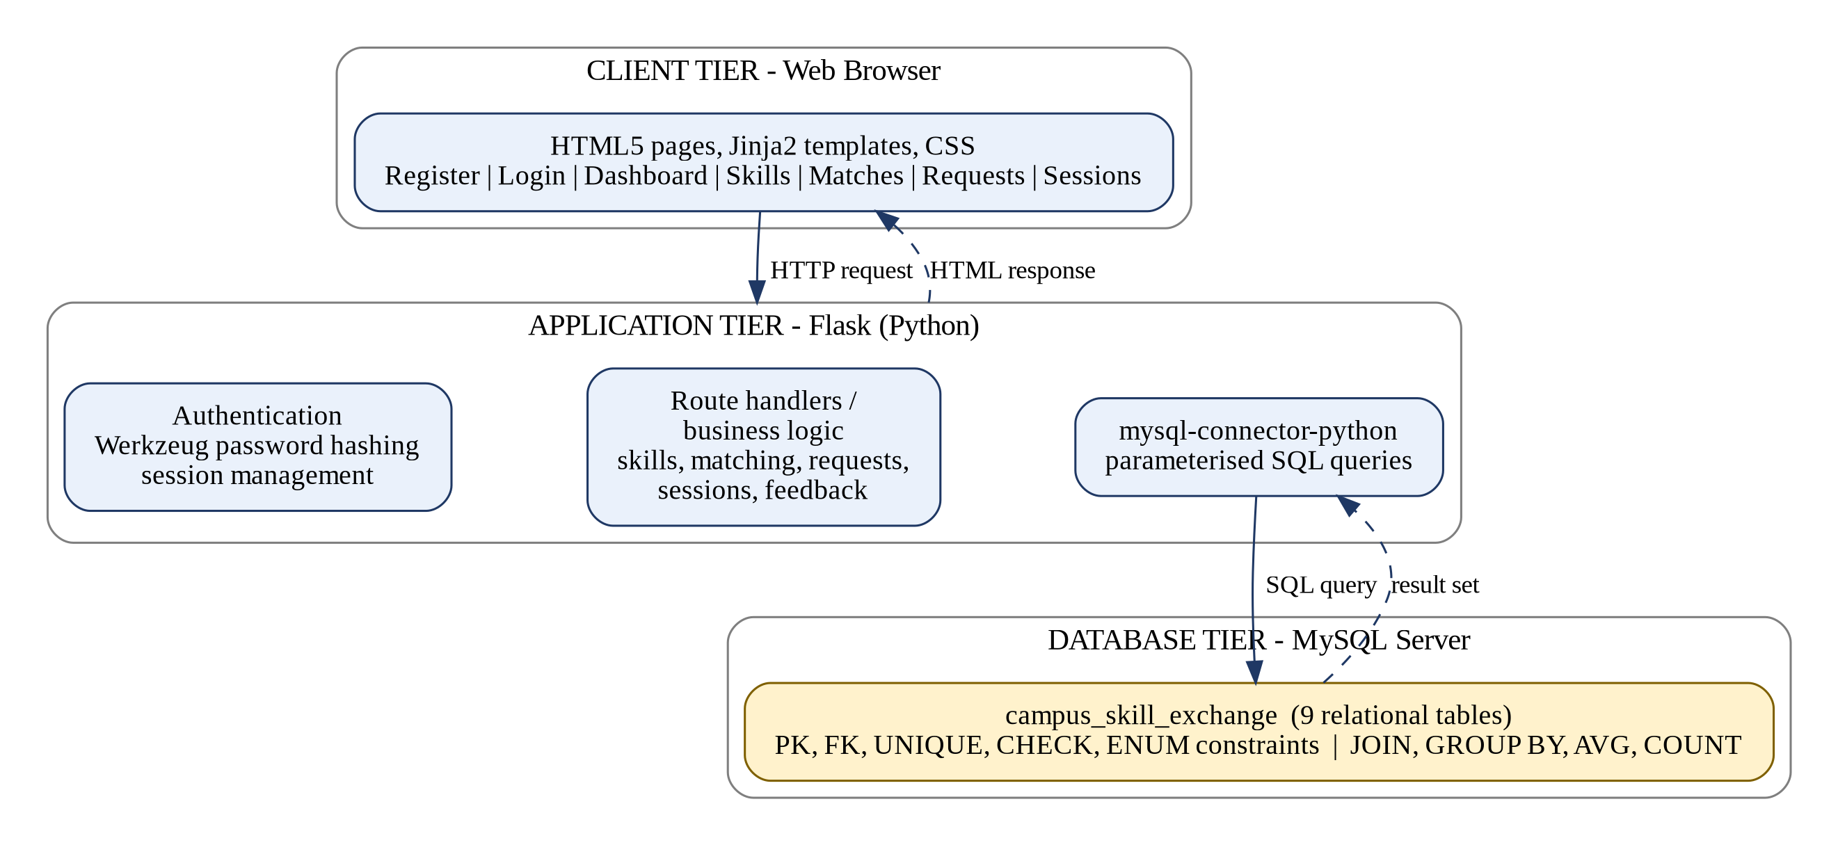
Fig. 4.1: Two-tier architecture of the proposed system

4.4 Workflow
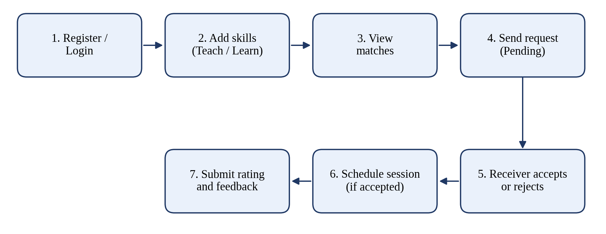
Fig. 4.2: Workflow from registration to feedback

5. Methodology / Implementation

5.1 Tools and Technologies Used
Component | Technology | Purpose
Database | MySQL | Relational storage, constraints, joins and aggregates
Back end | Python 3 with Flask 3.1.2 | Routing, session handling and business logic
DB connector | mysql-connector-python 9.4.0 | Executes parameterised SQL from Python
Security | Werkzeug 3.1.3 | Password hashing and verification
Front end | HTML5, Jinja2, CSS | Templates and styling of the pages
Tools | MySQL Workbench, web browser | Running schema.sql and testing the application
Table 5.1: Tools and technologies

5.2 Database Design
The database consists of nine tables. Student, category and skill store the master data. The tables student_teaches and student_learns are bridge tables that implement the many-to-many relationship between students and skills, each with a composite primary key (student_id, skill_id). The tables learning_request, session and feedback record the workflow, and availability stores the free time slots of a student. Fig. 5.1 shows the schema and the relationships between the tables.
Relationships
- One category has many skills (1:N); the foreign key skill.category_id is set to NULL if a category is deleted.
- Student and skill are related M:N through student_teaches and student_learns.
- A student sends and receives many learning requests; each request is for one skill.
- An accepted request can have scheduled sessions (1:N); each session has many feedback entries, at most one per student.
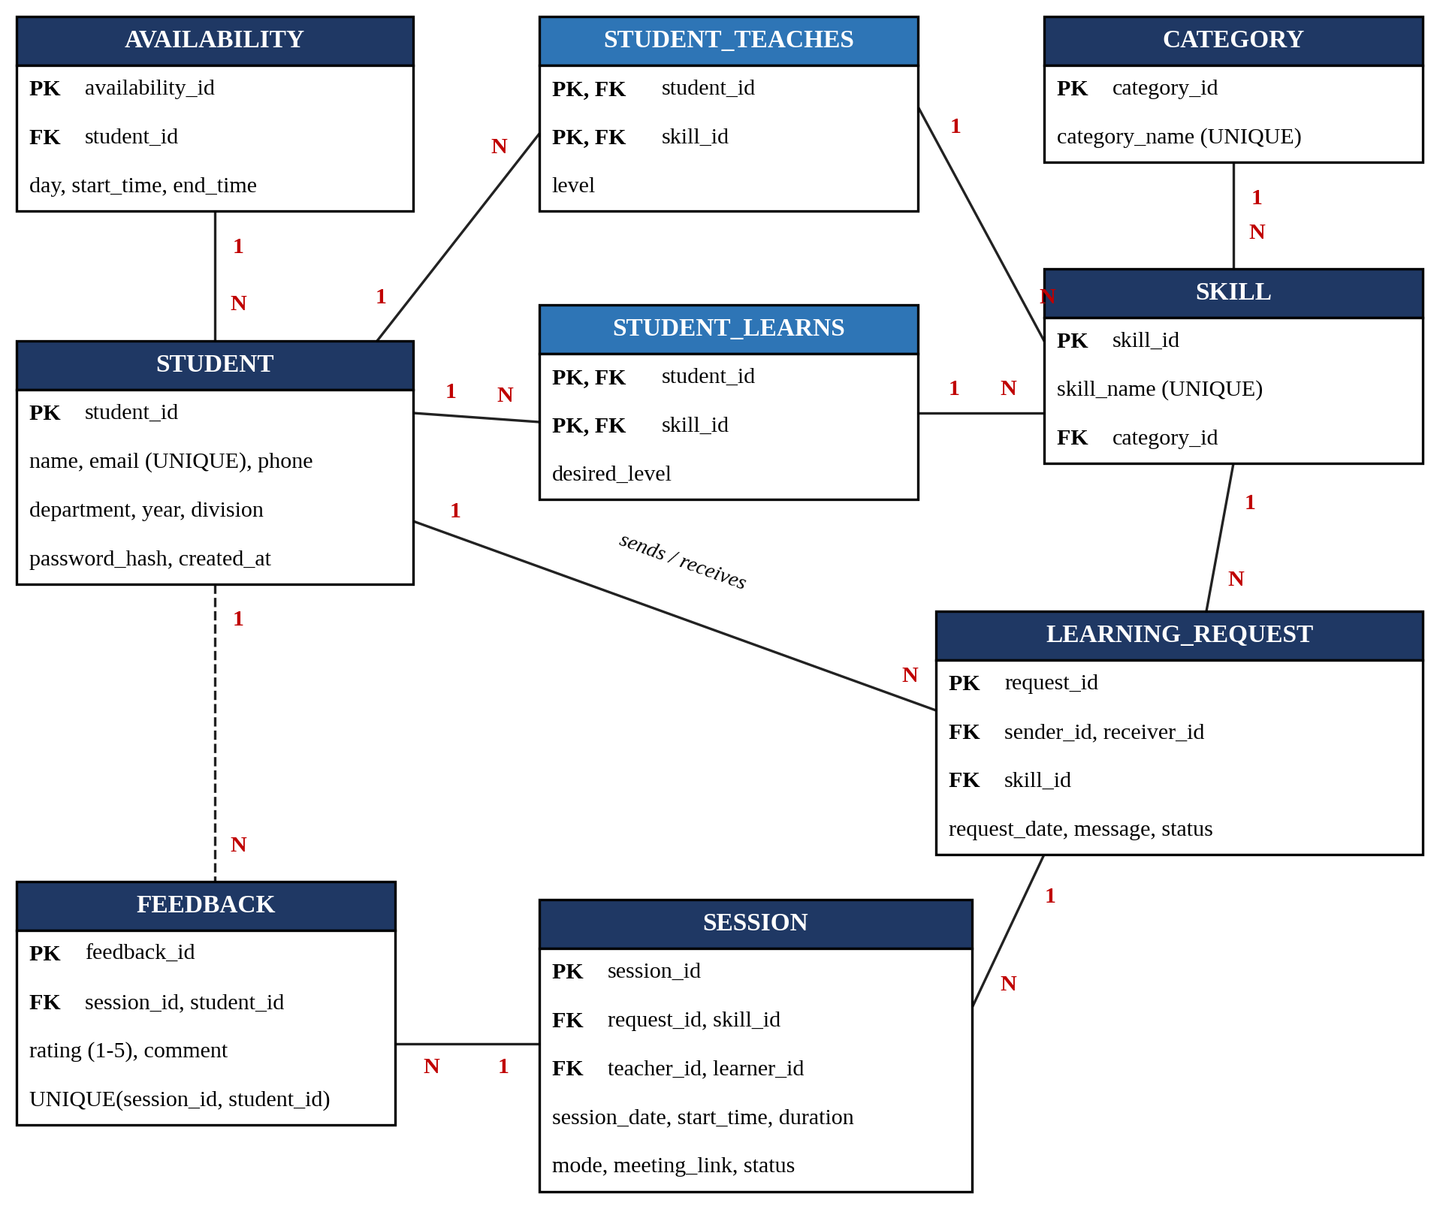
Fig. 5.1: Relational schema and entity relationships

5.3 Data Dictionary
Column | Data type | Constraints / Remarks
student_id | INT | PRIMARY KEY, AUTO_INCREMENT
name | VARCHAR(100) | NOT NULL
email | VARCHAR(120) | NOT NULL, UNIQUE
phone | VARCHAR(20) | Optional
department | VARCHAR(80) | NOT NULL
year | INT | NOT NULL, CHECK (year BETWEEN 1 AND 4)
division | VARCHAR(20) | NOT NULL
password_hash | VARCHAR(255) | NOT NULL, stores the salted hash only
created_at | TIMESTAMP | DEFAULT CURRENT_TIMESTAMP
Table 5.2: student
Column | Data type | Constraints / Remarks
category.category_id | INT | PRIMARY KEY, AUTO_INCREMENT
category.category_name | VARCHAR(80) | NOT NULL, UNIQUE
skill.skill_id | INT | PRIMARY KEY, AUTO_INCREMENT
skill.skill_name | VARCHAR(100) | NOT NULL, UNIQUE
skill.category_id | INT | FOREIGN KEY → category, ON DELETE SET NULL
Table 5.3: category and skill
Column | Data type | Constraints / Remarks
student_id | INT | Part of composite PRIMARY KEY; FOREIGN KEY → student, ON DELETE CASCADE
skill_id | INT | Part of composite PRIMARY KEY; FOREIGN KEY → skill, ON DELETE CASCADE
level / desired_level | ENUM | Beginner, Intermediate or Advanced; DEFAULT ‘Beginner’
Table 5.4: student_teaches (level) and student_learns (desired_level)
Column | Data type | Constraints / Remarks
request_id | INT | PRIMARY KEY, AUTO_INCREMENT
sender_id, receiver_id | INT | FOREIGN KEYS → student, ON DELETE CASCADE
skill_id | INT | FOREIGN KEY → skill, ON DELETE CASCADE
request_date | TIMESTAMP | DEFAULT CURRENT_TIMESTAMP
message | VARCHAR(500) | Optional note from the learner
status | ENUM | Pending, Accepted, Rejected, Completed, Cancelled; DEFAULT ‘Pending’
Table 5.5: learning_request
Column | Data type | Constraints / Remarks
session_id | INT | PRIMARY KEY, AUTO_INCREMENT
request_id | INT | FOREIGN KEY → learning_request, ON DELETE CASCADE
teacher_id, learner_id | INT | FOREIGN KEYS → student, ON DELETE CASCADE
skill_id | INT | FOREIGN KEY → skill, ON DELETE CASCADE
session_date, start_time | DATE, TIME | NOT NULL
duration | INT | NOT NULL (minutes)
mode | ENUM | Online or Offline; DEFAULT ‘Online’
meeting_link | VARCHAR(500) | Optional
status | ENUM | Scheduled, Completed, Cancelled; DEFAULT ‘Scheduled’
Table 5.6: session
Column | Data type | Constraints / Remarks
feedback.feedback_id | INT | PRIMARY KEY, AUTO_INCREMENT
feedback.session_id, student_id | INT | FOREIGN KEYS, ON DELETE CASCADE; UNIQUE(session_id, student_id)
feedback.rating | INT | NOT NULL, CHECK (rating BETWEEN 1 AND 5)
feedback.comment | VARCHAR(500) | Optional
availability.availability_id | INT | PRIMARY KEY, AUTO_INCREMENT
availability.student_id | INT | FOREIGN KEY → student, ON DELETE CASCADE
availability.day | ENUM | Monday to Sunday
availability.start_time, end_time | TIME | NOT NULL
Table 5.7: feedback and availability

5.4 Normalization
Every table has atomic column values and a primary key, so the schema is in First Normal Form. In student_teaches and student_learns the only non-key attribute (the level) depends on the whole composite key, so there are no partial dependencies, and the other tables use single-column keys, which places the schema in Second Normal Form. Skill categories are held in a separate table instead of being repeated as text in every skill row, which removes the transitive dependency of category name on skill and gives Third Normal Form for the master data.
One deliberate exception exists. The session table stores teacher_id, learner_id and skill_id, which can also be derived from the linked learning_request. This small redundancy was kept so that session listings and rating calculations need fewer joins.

5.5 Modules Description
- Authentication module. Registers students after checking for a duplicate email, stores a salted hash created by Werkzeug, and verifies the hash at login. The student_id is stored in the Flask session, and a login_required decorator protects every private page.
- Skill management module. Lets a student add skills to the “can teach” or “wants to learn” list, with a level, and remove them. A check prevents the same skill from being added twice to one list.
- Matching module. Runs a join query that finds students who teach a skill the current student wants to learn, excludes the student himself or herself, and orders the result by average rating.
- Request module. Inserts a learning request with status Pending, blocks duplicate pending requests, and lets only the receiver accept or reject a pending request.
- Session module. Allows either participant of an Accepted request to schedule a session. The request’s receiver is recorded as teacher and the sender as learner.
- Feedback module. Stores one rating (1–5) and an optional comment per student per session, after confirming that the student took part in the session.
- Dashboard module. Shows the student profile, both skill lists and a count of pending requests received.

5.6 Algorithms
A. Peer matching algorithm
- Take the student_id of the logged-in student (X).
- Select all skills that X wants to learn from student_learns.
- For each such skill, find the rows in student_teaches with the same skill_id and a different student_id.
- Join with student and skill to get names, department, year, skill name and level.
- Left-join the session and feedback tables to calculate the average rating of the teacher for that skill; a teacher without feedback gets 0 and is shown as a “new mentor”.
- Group by teacher and skill, and sort by rating (highest first) and then by name.
B. Request life cycle
A request is created as Pending. Only its receiver can change it to Accepted or Rejected, and the update succeeds only if the current status is still Pending. A session can be created only from an Accepted request. The status values Completed and Cancelled are defined in the schema for future use.

5.7 Important SQL Statements
Peer matching query
SELECT DISTINCT s.student_id, s.name, s.department, s.year,
sk.skill_name, st.level, COALESCE(AVG(f.rating),0) AS rating
FROM student_learns me
JOIN student_teaches st ON st.skill_id = me.skill_id
AND st.student_id <> me.student_id
JOIN student s ON s.student_id = st.student_id
JOIN skill sk ON sk.skill_id = st.skill_id
LEFT JOIN session se ON se.teacher_id = s.student_id
AND se.skill_id = sk.skill_id
LEFT JOIN feedback f ON f.session_id = se.session_id
WHERE me.student_id = %s
GROUP BY s.student_id, s.name, s.department, s.year, sk.skill_name, st.level
ORDER BY rating DESC, s.name;

Learning request listing (sent and received)
SELECT lr.*, s1.name AS sender_name, s2.name AS receiver_name, sk.skill_name
FROM learning_request lr
JOIN student s1 ON lr.sender_id = s1.student_id
JOIN student s2 ON lr.receiver_id = s2.student_id
JOIN skill sk ON lr.skill_id = sk.skill_id
WHERE lr.sender_id = %s OR lr.receiver_id = %s
ORDER BY lr.request_date DESC;

Accepting a request (only by the receiver, only while pending)
UPDATE learning_request
SET status = 'Accepted'
WHERE request_id = %s AND receiver_id = %s AND status = 'Pending';

5.8 Security and Integrity Measures
- Passwords are never stored in plain text; Werkzeug generates and checks salted hashes.
- All SQL statements use placeholders (%s) so user input is not concatenated into queries, which protects against SQL injection.
- Private pages need a login session, and request updates include the receiver’s own student_id so a user cannot act on another user’s request.
- PRIMARY KEY, FOREIGN KEY, UNIQUE, CHECK and ENUM constraints keep the data valid, and ON DELETE CASCADE removes dependent rows automatically.

5.9 Screenshots or Outputs
The figures below are placeholders for screenshots of the running application; the application pages are listed in Section 5.5. Sample query outputs are given in Chapter 6.
[ Insert screenshot: Home page and Registration page ]
Fig. 5.2: Home and registration pages
[ Insert screenshot: Dashboard and Skills page ]
Fig. 5.3: Dashboard and skill management
[ Insert screenshot: Matches page ]
Fig. 5.4: Peer matches
[ Insert screenshot: Requests and Sessions pages ]
Fig. 5.5: Requests and sessions

6. Results and Discussion

6.1 Outputs Achieved
The system was tested with a small set of sample records: four students, the 16 skills and 6 categories loaded by schema.sql, two learning requests that were accepted, one pending request, and two completed sessions with feedback. The outputs below were produced by running the project’s own matching query and related queries on this sample data. The names are fictitious.
Output 1: Peer matches for student Aarav Patil (wants to learn Python and UI/UX Design)
ID | Teacher | Department | Year | Skill | Level | Avg rating
2 | Isha Kulkarni | CSBS | 2 | Python | Advanced | 5.0
2 | Isha Kulkarni | CSBS | 2 | UI/UX Design | Intermediate | 0 (new)
3 | Rohan Desai | Computer | 3 | Python | Intermediate | 0 (new)
4 | Sneha Joshi | IT | 2 | UI/UX Design | Advanced | 0 (new)
Table 6.1: Output of the matching query
Isha Kulkarni appears first for Python because she already has a rating of 5.0 from a completed session, while mentors without feedback are listed after her in alphabetical order.
Output 2: Learning requests
Request | Sender (learner) | Receiver (teacher) | Skill | Status
1 | Aarav Patil | Isha Kulkarni | Python | Accepted
2 | Isha Kulkarni | Aarav Patil | C++ | Accepted
3 | Sneha Joshi | Rohan Desai | Python | Pending
Table 6.2: Learning requests
Output 3: Scheduled sessions
Session | Skill | Teacher | Learner | Date | Mins | Mode
1 | Python | Isha Kulkarni | Aarav Patil | 2026-10-05 | 60 | Online
2 | C++ | Aarav Patil | Isha Kulkarni | 2026-10-07 | 45 | Offline
Table 6.3: Sessions created from accepted requests
Output 4: Demand for skills (learners per skill)
SELECT sk.skill_name, COUNT(*) AS learners
FROM student_learns sl JOIN skill sk ON sk.skill_id = sl.skill_id
GROUP BY sk.skill_name ORDER BY learners DESC, sk.skill_name;

Skill | Learners
Python | 2
C++ | 1
Machine Learning | 1
UI/UX Design | 1
Table 6.4: Skill demand report
Output 5: Mentor ratings
SELECT t.name, ROUND(AVG(f.rating),1) AS avg_rating, COUNT(f.feedback_id) AS reviews
FROM feedback f JOIN session se ON se.session_id = f.session_id
JOIN student t ON t.student_id = se.teacher_id
GROUP BY t.name ORDER BY avg_rating DESC;

Teacher | Average rating | Reviews
Isha Kulkarni | 5.0 | 1
Aarav Patil | 4.0 | 1
Table 6.5: Mentor rating report
Note: Tables 6.1–6.5 were generated on test data only. They show the behaviour of the queries and are not results from real users.

6.2 Performance
No formal load testing was done, so no timing figures are reported. The test database responded instantly to every page. For larger data, the PRIMARY KEY and UNIQUE constraints create indexes on student_id, skill_id, email and the composite keys of the bridge tables, and these indexes support the joins used in the matching query. Adding indexes on learning_request(receiver_id, status) and session(teacher_id, skill_id) would help further as data grows.

6.3 Integrity Checks Observed
Test | Expected behaviour
Register with an existing email | Rejected with the message “Email already registered” (UNIQUE constraint and application check)
Add the same skill twice to one list | Rejected with a warning; the composite primary key prevents duplicates
Send a second pending request for the same skill and teacher | Blocked by the application check
Accept a request as someone other than the receiver | No update, because the WHERE clause includes receiver_id
Submit feedback twice for one session | Second entry is ignored (UNIQUE(session_id, student_id))
Rating outside 1–5 | Rejected by the CHECK constraint (on MySQL 8.0.16 or later, which enforces CHECK)
Table 6.6: Integrity checks

6.4 Comparison with Existing Methods
Feature | Chat groups / notice boards | Online course platforms | Paid tutoring sites | Proposed system
Campus-specific peers | Partly | No | No | Yes
Automatic skill matching | No | No | Partly | Yes
Request and approval workflow | No | No | Yes | Yes
Session scheduling record | No | No | Yes | Yes
Ratings and feedback | No | Yes (courses) | Yes | Yes
Free to use | Yes | Partly | No | Yes
Data integrity constraints | No | Not applicable | Not applicable | Yes
Table 6.7: Comparison with existing methods

7. Conclusion and Future Scope

7.1 Summary of Achievements
The project successfully applies the concepts of the DBMS course to a practical campus problem. A nine-table relational schema was designed with keys, constraints and cascading rules, and a Flask application was built on top of it. The system allows a student to register, list teachable and desired skills, find matching peers through a SQL join query, send and accept requests, schedule sessions and give feedback. The work meets the course outcome of designing a database schema and a two-tier application.

7.2 Limitations
- Triggers, views, stored procedures and cursors, which the course outcomes mention, are not used yet.
- The availability table is part of the schema but no page of the application uses it.
- The Completed and Cancelled statuses of requests and sessions have no user interface, so these records cannot be closed from the application.
- The average rating in the matching query counts feedback from both participants of a session, so a rating given by a teacher about the learner also affects the teacher’s score. Filtering to learner ratings only would fix this.
- Matching is one-directional (teachers of skills the user wants); mutual exchanges are not searched for.
- There is no administrator role or CSRF protection, the secret key and database password are written in the source file, and a skill is deleted through a plain link request. These must be changed before real deployment.

7.3 Future Scope
- Add triggers for automatic status updates, a view for mentor rankings, and stored procedures with explicit transactions for request acceptance and session booking.
- Use the availability table to suggest common free slots, and store notifications and chat messages in MongoDB to cover the NoSQL course outcome.
- Add an administrator panel, email or in-app notifications, mutual skill-swap matching and a mobile-friendly interface.

8. References
- Elmasri, R. and Navathe, S. B., Fundamentals of Database Systems, Pearson Education.
- Silberschatz, A., Korth, H. F. and Sudarshan, S., Database System Concepts, McGraw-Hill Education.
- Ramakrishnan, R. and Gehrke, J., Database Management Systems, McGraw-Hill.
- Codd, E. F., “A Relational Model of Data for Large Shared Data Banks”, Communications of the ACM, vol. 13, no. 6, 1970.
- Chen, P. P., “The Entity-Relationship Model – Toward a Unified View of Data”, ACM Transactions on Database Systems, vol. 1, no. 1, 1976.
- Topping, K. J., “The effectiveness of peer tutoring in further and higher education: A typology and review of the literature”, Higher Education, vol. 32, 1996.
- MySQL 8.0 Reference Manual, Oracle Corporation. https://dev.mysql.com/doc/
- Flask Documentation, Pallets Projects. https://flask.palletsprojects.com/
- Werkzeug Documentation (security utilities), Pallets Projects. https://werkzeug.palletsprojects.com/
- MySQL Connector/Python Developer Guide, Oracle Corporation. https://dev.mysql.com/doc/connector-python/en/

9. Appendix

A. Database schema (schema.sql, extract)
CREATE TABLE student (
student_id INT AUTO_INCREMENT PRIMARY KEY,
name VARCHAR(100) NOT NULL,
email VARCHAR(120) NOT NULL UNIQUE,
phone VARCHAR(20),
department VARCHAR(80) NOT NULL,
year INT NOT NULL CHECK (year BETWEEN 1 AND 4),
division VARCHAR(20) NOT NULL,
password_hash VARCHAR(255) NOT NULL,
created_at TIMESTAMP DEFAULT CURRENT_TIMESTAMP
);

CREATE TABLE student_teaches (
student_id INT NOT NULL,
skill_id INT NOT NULL,
level ENUM('Beginner','Intermediate','Advanced')
DEFAULT 'Beginner',
PRIMARY KEY(student_id, skill_id),
FOREIGN KEY(student_id) REFERENCES student(student_id) ON DELETE CASCADE,
FOREIGN KEY(skill_id) REFERENCES skill(skill_id) ON DELETE CASCADE
);

CREATE TABLE learning_request (
request_id INT AUTO_INCREMENT PRIMARY KEY,
sender_id INT NOT NULL,
receiver_id INT NOT NULL,
skill_id INT NOT NULL,
request_date TIMESTAMP DEFAULT CURRENT_TIMESTAMP,
message VARCHAR(500),
status ENUM('Pending','Accepted','Rejected',
'Completed','Cancelled') DEFAULT 'Pending',
FOREIGN KEY(sender_id) REFERENCES student(student_id) ON DELETE CASCADE,
FOREIGN KEY(receiver_id) REFERENCES student(student_id) ON DELETE CASCADE,
FOREIGN KEY(skill_id) REFERENCES skill(skill_id) ON DELETE CASCADE
);

CREATE TABLE feedback (
feedback_id INT AUTO_INCREMENT PRIMARY KEY,
session_id INT NOT NULL,
student_id INT NOT NULL,
rating INT NOT NULL CHECK(rating BETWEEN 1 AND 5),
comment VARCHAR(500),
feedback_date TIMESTAMP DEFAULT CURRENT_TIMESTAMP,
UNIQUE(session_id, student_id),
FOREIGN KEY(session_id) REFERENCES session(session_id) ON DELETE CASCADE,
FOREIGN KEY(student_id) REFERENCES student(student_id) ON DELETE CASCADE
);

B. Application code snippets (app.py)
Login with password verification
@app.route('/login', methods=['GET', 'POST'])
def login():
if request.method == 'POST':
email = request.form['email'].strip().lower()
password = request.form['password']
db = get_db(); cur = db.cursor(dictionary=True)
cur.execute('SELECT * FROM student WHERE email=%s', (email,))
user = cur.fetchone(); cur.close(); db.close()
if user and check_password_hash(user['password_hash'], password):
session['student_id'] = user['student_id']
session['name'] = user['name']
return redirect(url_for('dashboard'))
flash('Invalid email or password.', 'danger')
return render_template('login.html')

Sending a learning request (duplicate check and insert)
@app.route('/request/<int:receiver_id>/<int:skill_id>',
methods=['POST'])
@login_required
def send_request(receiver_id, skill_id):
sid = session['student_id']; message = request.form.get('message','')
db = get_db(); cur = db.cursor()
cur.execute('''SELECT request_id FROM learning_request
WHERE sender_id=%s AND receiver_id=%s
AND skill_id=%s AND status='Pending' ''',
(sid, receiver_id, skill_id))
if cur.fetchone():
flash('You already have a pending request for this skill.', 'warning')
else:
cur.execute('''INSERT INTO learning_request
(sender_id,receiver_id,skill_id,message,status)
VALUES(%s,%s,%s,%s,'Pending')''',
(sid, receiver_id, skill_id, message))
db.commit(); flash('Learning request sent.', 'success')
cur.close(); db.close()
return redirect(url_for('matches'))

C. Steps to run the project
- Install MySQL and open MySQL Workbench.
- Run schema.sql to create the database, tables and starting data (categories and skills).
- Open app.py and set the MySQL password in DB_CONFIG.
- Create a virtual environment, run pip install -r requirements.txt (Flask, mysql-connector-python, Werkzeug).
- Run python app.py and open http://127.0.0.1:5000 in a browser.

D. Project files
File / folder | Description
schema.sql | Database creation script with tables, constraints and initial data
app.py | Flask application: routes, authentication and SQL queries
requirements.txt | Python package list
templates/ | Jinja2 pages: base, index, register, login, dashboard, skills, matches, requests, sessions
static/style.css | Stylesheet for the web pages
README.md | Setup steps and a suggested demo
Table A.1: Project files
